Practical - 9
Practical Title: Secure User Registration with Database Insert, Duplicate Email Check, and Password Hashing

Problem Definition : Implement secure user registration by inserting user details into MySQL using MYSQLi. Validate input on frontend and backend, check duplicate email/username, hash passwords using password_hash(), and display appropriate messages.

Theory
1. Is password_hash() used before storing passwords?
Yes, password_hash() is used before storing the password, so the actual password is not stored directly in the database.

2. Is duplicate email/username checked?
Yes, the system checks whether the username or email already exists before inserting a new user.

3. Are frontend and backend validations consistent?
Yes, both frontend and backend validations check the same basic requirements such as username format, valid email, minimum password length, and matching passwords.

A. Evidence of Work (Screenshots):
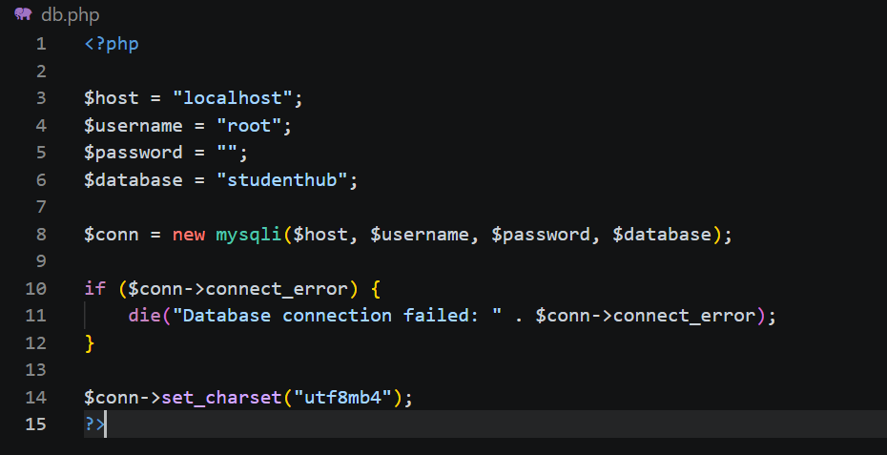

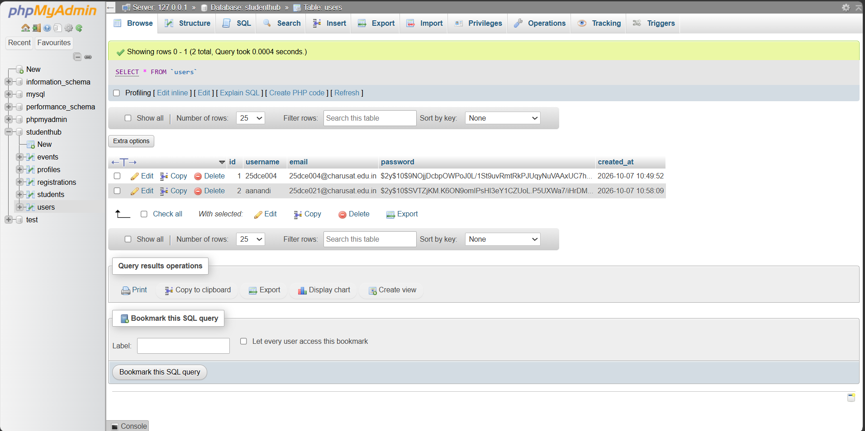

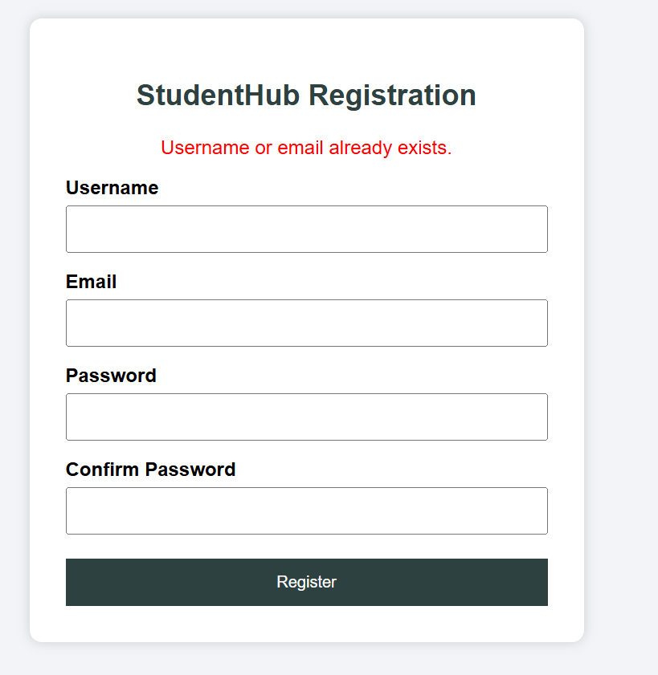
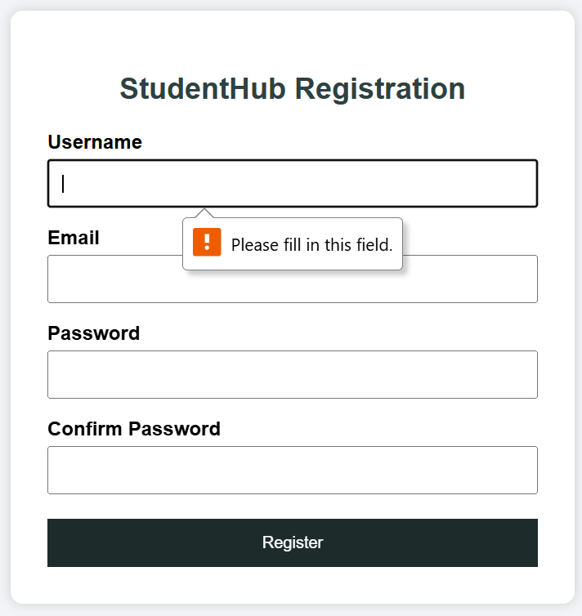
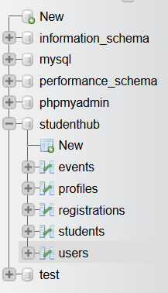

B.GitHub Repository Link:

https://github.com/Andarpadhruvi1125/Student-Hub-portal.git
C.Challenges Faced
During this practical, I faced some difficulties while creating the MySQL database and table. I also faced an error while connecting the PHP page with the MySQL database. Understanding PDO connection and prepared statements was a little difficult at first. I also had to make sure that the form field names and database column names were correct.
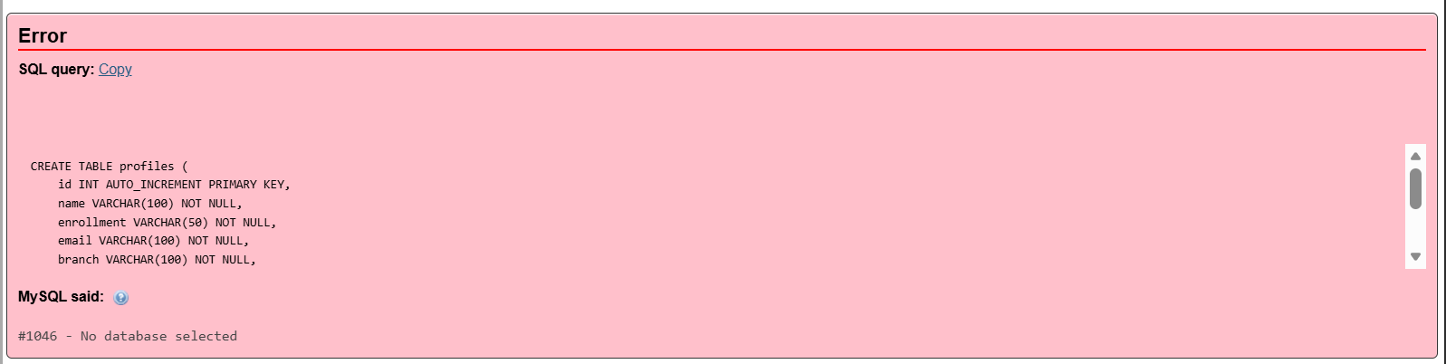


D.Learning Outcomes
From this practical, I learned how to create a MySQL database and table and connect PHP with MySQL using PDO. I learned how to insert form data into a database using prepared statements. I also understood the basic concepts of database schema, primary keys, and secure database operations.

Faculty Remarks:

